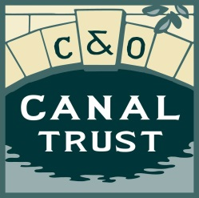

Sample Charitable Bequest Language

The following five clauses are standard. Please choose one. If you wish to be more specific, your lawyer or estate planner should draft the clause to meet your specific requirements.

Specific, unrestricted:

I give, devise and bequeath to the C&O Canal Trust the sum of $_________________ to be used for any purpose(s) approved by the Board of Directors of the C&O Canal Trust.

Specific, restricted with escape clause:

I give, devise and bequeath to the C&O Canal Trust the sum of $_________________ to be used for the following purpose(s):______________________________________________________. If the C&O Canal Trust is unable to apply all or part of these funds for the specific purpose(s) stated herein, C&O Canal Trust will redirect the gift to a new purpose that is as close as possible to the original intent of the donor.

General percentage, unrestricted:

I give, devise and bequeath to the C&O Canal Trust ____% of the residue of my estate to be used for any purpose(s) approved by the Board of Directors of the C&O Canal Trust.

General percentage, restricted with escape clause:

I give, devise and bequeath to the C&O Canal Trust ______% of my estate to be used for the following purpose(s): ________________________________________________________. If the C&O Canal Trust is unable to apply all or part of these funds for the specific purpose(s) stated herein, the C&O Canal Trust will redirect the gift to a new purpose that is as close as possible to the original intent of the donor.

Residual Contingent Trust
Upon the death of the survivor of my (wife, husband, etc.) ____________________ and my (son, daughter, etc.) _______________________, I direct my trustee to transfer and deliver the balance of the residue of my Estate, including any undistributed income to the C&O Canal Trust.

These are sample clauses only. Your lawyer or estate planner should always review clauses and ensure they are appropriate to your wishes, and comply with the law in your state.

