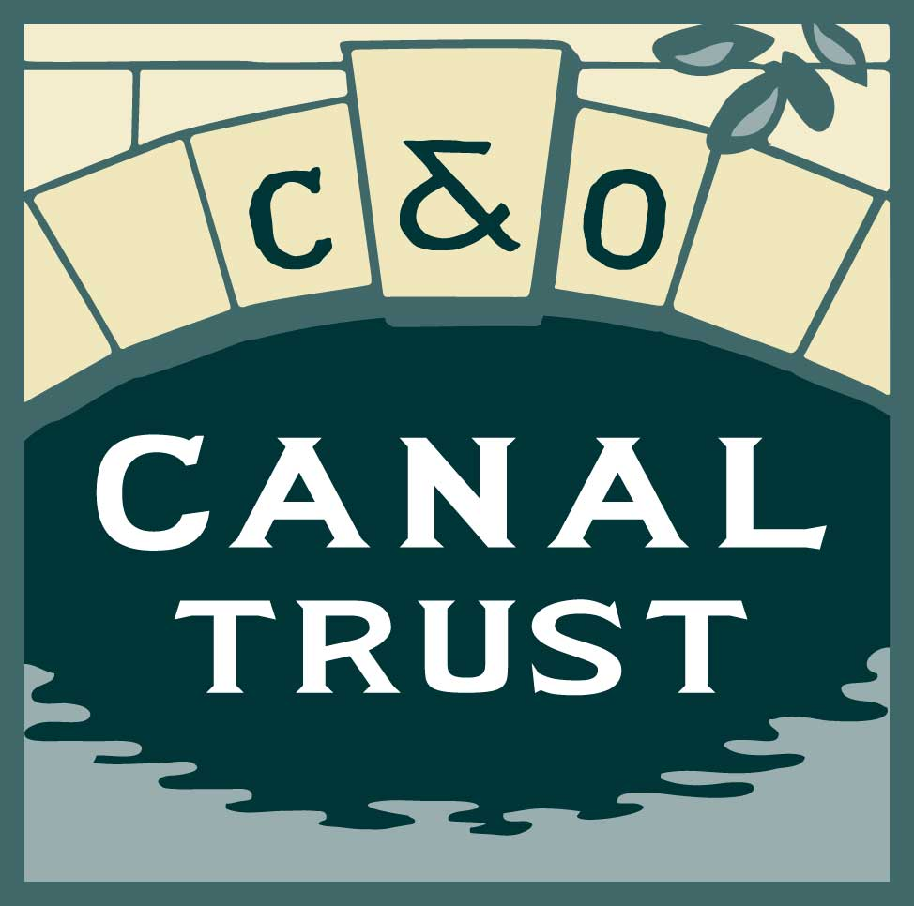
The Patowmack Society
Confidential Estate Gift Notification

Thank you for choosing to support the C&O Canal Trust, Inc. and our Park Partner, the C&O Canal National Historical Park, through an estate gift. It is useful, but not mandatory, for the C&O Canal Trust to receive a copy of the relevant section(s) of your will. Completing this form provides the C&O Canal Trust with written documentation of your bequest or estate gift intentions. Your information will be kept strictly confidential and we will recognize your legacy gift only with your permission.

This form is non-binding as we recognize that your financial situation and personal circumstances may change.

Donor Information
Name(s) ______________________________________________________________
Address ______________________________________________________________
City/State/Zip ______________________________________________________________
Phone ______________________________________________________________
Email Address ______________________________________________________________
Donor’s Date of Birth ____________________________ Spouse’s Date of Birth ______________

Trustee or Executor Information
Name(s) ______________________________________________________________
Address ______________________________________________________________
City/State/Zip ______________________________________________________________
Telephone(s) ______________________________________________________________
Email Address ______________________________________________________________

Donor Recognition
__Please list my/our name(s) as: _______________________________________________________ __I/We wish to remain anonymous.

BEQUEST and ESTATE ASSET INFORMATION Please note that many firms do not contact beneficiaries when the account holder is deceased. Therefore, if you designate the C&O Canal Trust, Inc. as a beneficiary of any account not covered by your will you must notify the C&O Canal Trust, Inc., so that we are aware of the designation and able to claim the assets when the time comes.

The C&O Canal Trust, Inc. is named as a beneficiary of the following (please check all that apply):
(If willing to share the information, please include the current estimated value of the asset.)
__A bequest intention has been designated in my/our will. The current estimated value of this bequest intention is: $________________.

__ A Retirement Account or Plan. The current estimated value of this asset is: $______________.
__ Life Insurance Policy. The current estimated value of this asset is: $_______________.
__ Investment or Financial Account. The current estimated value of this asset is: $_______________.

Gift Designation
I/We wish our gift to be designated to the following:
__ Funds may be used for any purpose(s) approved by the Board of Directors of the C&O Canal Trust.
__ I/We request that funds be used to support Park Partner programs and/or fundraising initiatives on behalf of the C&O Canal National Historical Park:
_____ Towpath Forever
_____ Canal Classrooms
_____ Canal Quarters
_____ Canal Pride
_____ Canal Discoveries
_____ Canal Towns

Additional information or directions regarding our gift designation: _______________________________________________________________________________________________________________________________________________________________________________________________________________________________________________________________

Signature: ___________________________Date:____________

Signature: ___________________________Date: ____________

Please return this form to:
Patricia Barber
Director of Development
C&O Canal Trust, Inc.
1850 Dual Highway, Suite 100
Hagerstown, MD 21470
301-745-8880
barber@canaltrust.org

Thank you again for your continued support of the C&O Canal Trust and its Park Partner, the C&O Canal National Historical Park and for sharing your plans with us. The C&O Canal Trust is the official nonprofit partner of the C&O Canal National Historical Park, and a registered
501(c)(3) organization.

